How to clone a Git repository from Atlassian into an Eclipse workspace to work on it.

Create a directory for the Eclipse project and for the local Git repository. These directories may already exist, as it is possible to have more than one Git repository in a directory, each in a sub-folder, and more than one maven project in an Eclipse working directory. In this note, these will be called eclipse and git, and should be understood to represent the complete path to these directories. An existing project called Certificates is used for the example.

Open Eclipse. If you do not have a “default and don't ask” workspace selected, Eclipse will display the “Workspace Launcher” dialog. If you have a default workspace, it will open automatically; select File > Switch Workspace > Other... to open the launcher. Using the Browse... command button, move to your eclipse directory, then click OK.

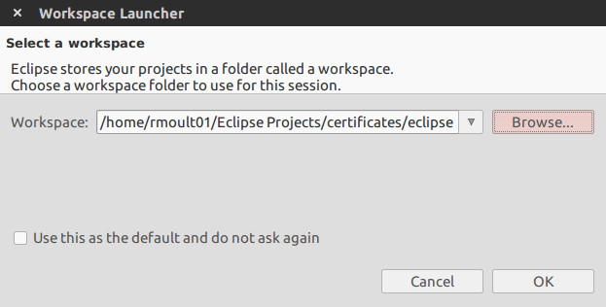

At this point, Eclipse will open an new workspace in your eclipse directory. Close the Welcome perspective if needed. Open the Git perspective.
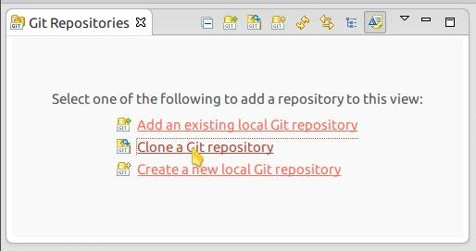

In the Git Repositories window, select the Clone a Git repository wizard, which will open the Clone Git Repository dialog. Leave that dialog open, we'll come back to it shortly.
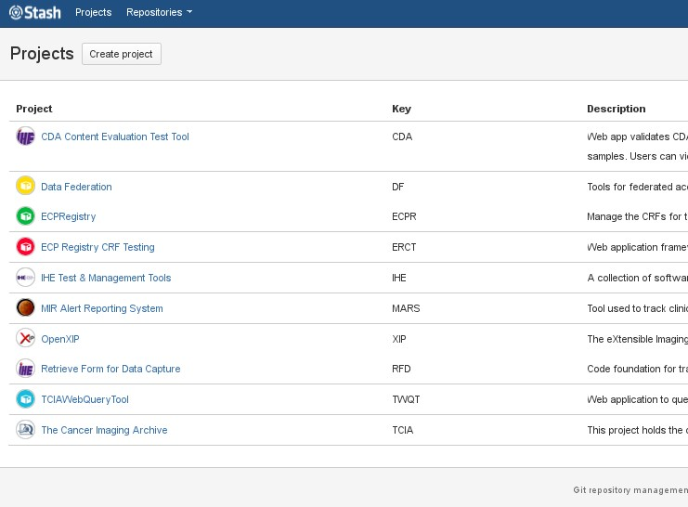

In a web browser, surf to your Atlassian Stash - in ERL our URL is https://code.imphub.org/projects - and log in if needed. Click on the appropriate project to access the Git repositories. In this note, we click on “IHE Test & Management Tools”, and then the particular repository, “Certificates”:
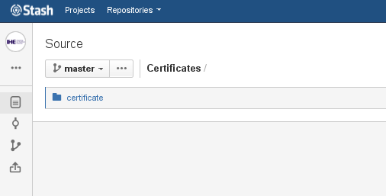

You may need to select the branch you want, although for ERL, this is almost always the default, “master”. Hover your mouse over the elipsis (…) in the left margin, not the one next to “master”,
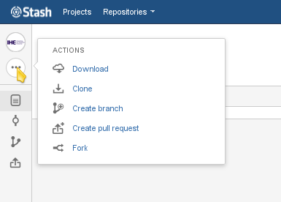

then click on the “clone” item on the popup menu. This will open up a small dialog box with the repository URI in it, already selected. Right click and select copy or just Ctrl-c to copy this URI to the clipboard.

Now, return to the Clone Git Repository and paste the URI from Atlassian into the Location block URI: text box. When you do this, all the other necessary fields except for your Atlassian password will be filled in automatically:

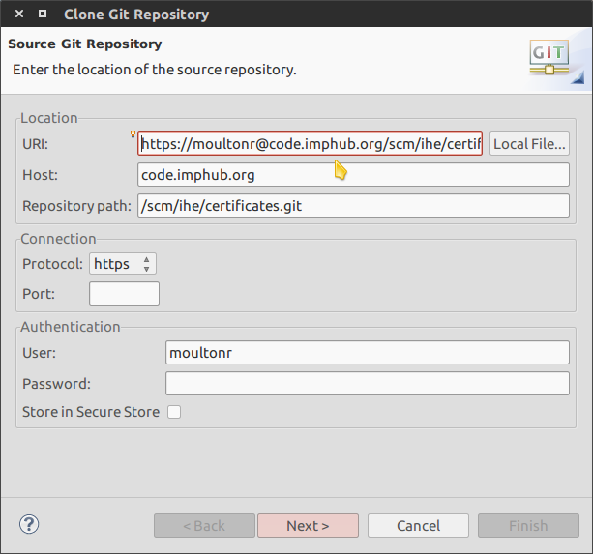

Enter your password in the Authentication block Password: textbox and click the “Next>” command button.

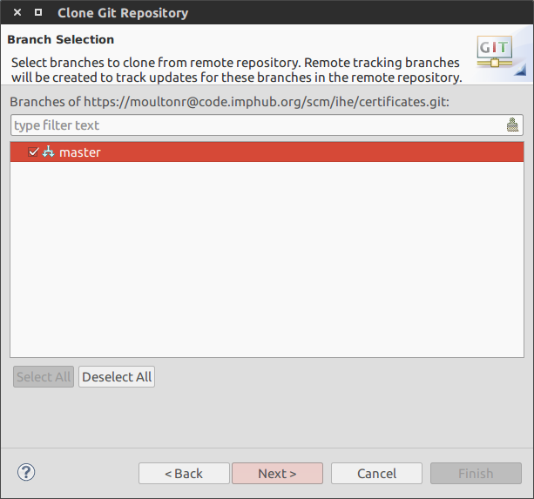

Select the branch you want to clone, almost always master, and click the “Next>” command button:

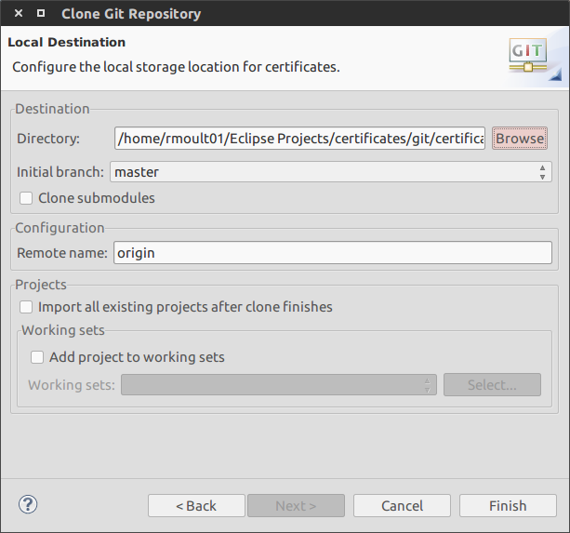

In the Destination block, use the Browse command button to go to your git directory. The browse dialog will add a directory named for the project – in our case, “certificates” - inside your git directory; this is fine. Click the “Finish” command button. A batch dialog will appear while the repository is cloned, then your Git Repositories window will show the local repository it has cloned:
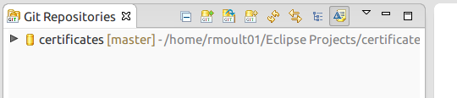

Open the JavaEE perspective. From the main menu, select File>Import...

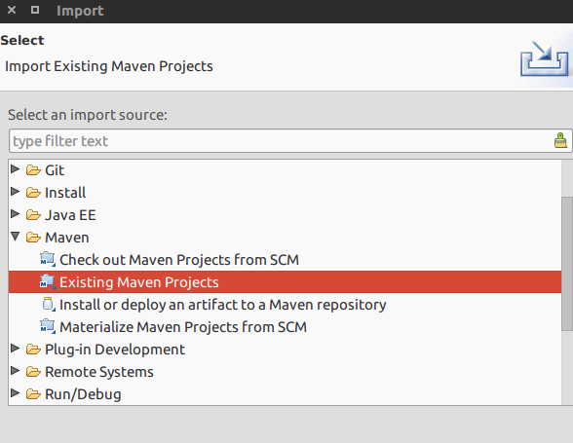

In the Import wizard select panel, drill down to Maven, Existing Maven Projects, select it, and click the “Next>” command button:

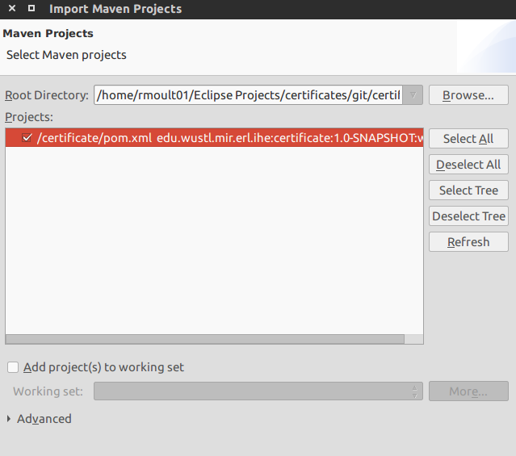

In the Import Wizard Maven Projects panel, click the Browse... command button and use the file selection dialog to select the root directory of the project. This is NOT the git directory. It is the directory inside the git directory that the project was cloned to, in our case, git/certificates. Click the Finish command button. A batch process dialog will open while the project is imported to Eclipse, then you are finished.

